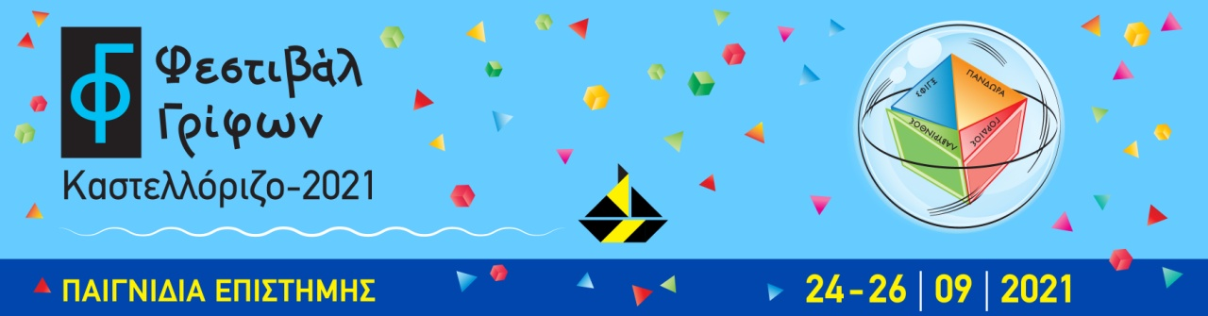

Press Release
1st Kastellorizo Puzzle Festival, 15 days before its launch (24-26/9/21)
A great effort, an important idea is approaching its realization, with many expectations both for this year's event and for future prospects. Our main goal is for scientific knowledge to reach everyone – young and old – in a simple, accessible and enjoyable way.
For this reason, there will be no speeches of academic style, but simple discussions, scientific events in the form of a game or theatrical narration, impressive experiments that will explain everyday topics, tours, Stand up Science for children, exhibitions, theatrical / musical workshops and workshops where children will learn to construct “karagiozis” figures, and especially countless puzzles that will persistently ask for their solution.
The following examples include just a few of the numerous activities:
- The mathematician and founder of the Puzzle Museum, Pantazis Houlis, will highlight what a puzzle is through simple speeches ("Trojan Puzzle", "Archimedes Ostomachion"), and in addition there will be an enriched lecture on Kastellorizo.
- Michael Toulouzas, award-winning puzzle maker and member of the International Puzzle Party, will present an impressive exhibition with samples of his award-winning puzzles.
- The distinguished professor of the University of Crete, Michael Lambrou, will approach mathematics through entertaining narratives and mathematical tricks.
- Kosmas Gazeas, astrophysicist, from the Department of Astrophysics at the University of Athens, will show visitors how to touch the planets and travel mentally in our solar system through his interactive exhibition Planets In Your Hand.
- Researchers
(a) from the Hellenic Centre for Marine Research will present innovative actions on the marine environment and will discuss with children about the marine ecosystem,
(b) from the Pasteur Institute will stimulate interest by playing with the curiosity of the public on biology and public health issues,
(c) from the Eugenides Foundation/ Science and Technology Center will amaze with The Mathemagic and a series of original chemical experiments, and
- finally, the program could not miss out on the educational robotics / Stem courses entitled "My first automations" by the well-known organization Stem Education.

In the next Press Release we will refer in detail to the part of the festival that connects Art with Science.

The organization is coordinated by the Megisti Puzzle Museum and the Association EN.I.G.MA (Union of Ideas, Puzzles, Mathematics) in collaboration with Eleni Grammatikopoulou. It is under the auspices of the General Secretariat for Research and Innovation, the Ministry of Development and Investments and the Ministry of National Defence. It is co-organized by the Region of South Aegean. It takes place with the pro bono offer of more than 50 participating researchers, academics, and educational institutions.

For more information visit our site: https://kastellorizofestival.com/
Contact information:
Pantazis Houlis: Organiser/Megisti Puzzle Museum:
e-mail: pandahou@yahoo.com – T +30 22460 49454 & +30 6980865814

Eleni Gramatikopoulou: Co-Organiser:
e-mail: eleni.gramma@gmail.com - Τ. +30 2106395458 & +30 697 4228637

