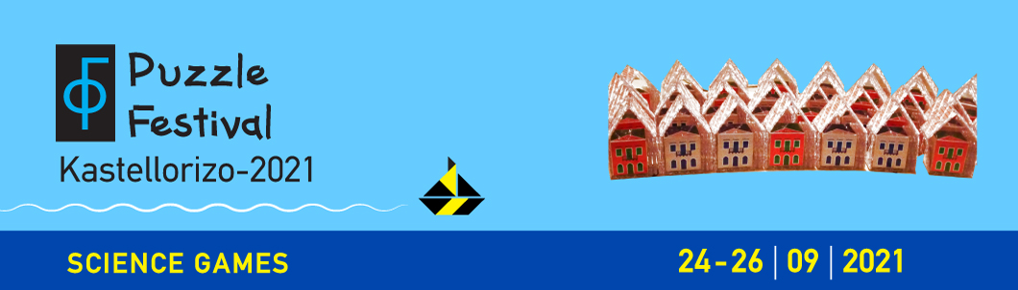

Press Release
In a few days, Kastellorizo welcomes its own 1st Puzzle Festival (24-26/9/21)
For three days this small remote island will become the focus of scientific knowledge, hosting a plethora of scientific events, impressive experiments, original actions, games and workshops that will be interpret every day matters in a simple and understandable way and will present modern scientific concepts.
More than 50 scientists, researchers, educators, writers, actors and artists prepared their “puzzling” presentations, adapting them specifically to the requirements of this special festival. At the same time, Art in combination with Science will give an interesting and entertaining presence! Specifically:
The subversive team of Science Reactors with the well-known Stand up Science kids will give their own scientific guidelines “for the vaccine of love, to marined teenagers” on how to avoid the stress of learning, they will talk about artificial intelligence and the thought/computer relationship and will ask themselves "what is hacking" and if indeed there is the science of keeping secrets!
There will be narration of fairy tales by the authors themselves and discussion with them. Michelle Kiosoglous will present her book "Kleio and Despina" with the manners, customs and tradition of Kastellorizo. Christos Kalountzoglou will talk about the fairy tale "The wet plank" and the pirate Manny Manny in Kastellorizo, a figure taken from the Greek archipelago, kneaded with saltiness and the adventures of the sea.
Music Lab – Theatrical Play by the actress Fotini Baxevani and construction of shadow theatre & Karagiozis figures by Christos Stanisis. Being inspired, creating a story of your own and expressing it through the magical world of theatre and music is not a... puzzle? But it's also a game! And if it seems like a brain teaser, then join their workshop!
The "Crew 94", the cheerful team from Patras, will conquer young and old with its Navigations and treasure hunt and will impress them with many surprises. The Puzzle Museum will be waiting for their visitors for guided tours.
From this year onwards, an international competition will be part of the Puzzle Festival: the “Megistian Aenigma Agon”. But what is this Agon? It is a Quadruple International Competition (inscription, illusion, invention and interaction). It is a celebration of games and puns for children from 0 to 150 years old, which presents to the world the leading role of Greece in puzzles and riddles!
The MAA (as well as the 14th KEC Puzzle Exhibition that began in 2008) will be part of the Kastellorizo Puzzle Festival.

In addition, the Festival reserves cultural/scientific evenings: Karagiozis performance, Star-observation, and concert with favorite folk, rebetika and Smyrneika songs with Tutti Blue and the well-known Stathis Raftopoulos singing.

The whole event is coordinated by the Megisti Puzzle Museum and the EN.I.G.MA Club (Union of Ideas, Puzzles, Mathematics) in collaboration with Eleni Grammatikopoulou. It is under the auspices of the General Secretariat for Research and Innovation, the Ministry of Development and Investments, the Ministry of National Defence and the Ministry of Culture and Sports. The PF is co-organized with the Region of South Aegean and is dynamically supported by the Municipality of Megisti. The PF could not have taken place without the pro bono participation of more than 50 researchers, academics, and educational institutions and the courtesy of other private sponsors. We thank them all for their trust and support.

For more information, please visit our website: https://kastellorizofestival.com/
Contact details:
Pantazis Houlis: Organiser/Megisti Puzzle Museum:
e-mail: pandahou@yahoo.com - Ph. +30 22460 49454 & +30 6980865814

Eleni Grammatikopoulou:Co-organizer/Science Communication
e-mail: eleni.gramma@gmail.com - Ph. +30 2106395458 & +30 697 4228637

