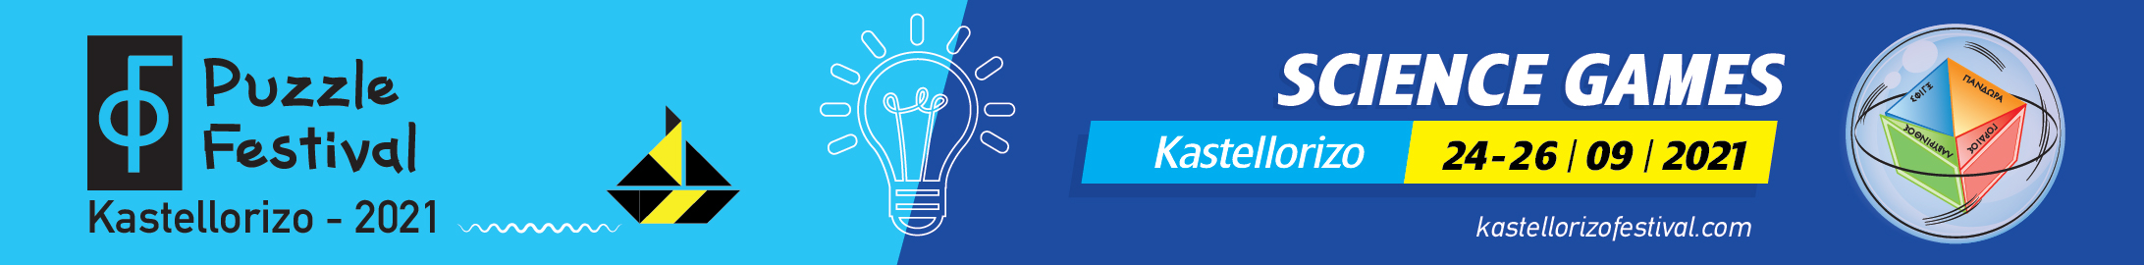

1st KASTELLORIZO PUZZLE FESTIVAL: A DREAM THAT BECAME REALITY

More than fifty scientists, researchers and artists shared the dream of the founder of the Megisti Puzzle Museum, Pantazis Houlis - who embodied the idea of Eleni Grammatikopoulou - and enthusiastically took part in the three-day events of the 1st Kastellorizo Puzzle Festival.

From 24 to 26 September, thanks to the excellent organization of Eleni Grammatikopoulou, one of the very few experts in the field of science communication, and the hospitable host Pantazis Ηoulis, the first Kastellorizo Puzzle Festival was completed with absolute success.
The result was that the locals of Kastellorizo, young and old, came together with the scientists and artists who went to the island from Athens, Crete, Patras and Thessaloniki.

Kastellorizo came to the center of international scientific interest, thanks to actions developed in four axes by using puzzles as the main theme:
(a) scientific experiments and discussions
b) science games for young and old
c) exhibitions (puzzles and astrophysics)
d) artistic workshops for children and actions that brought together arts and science.

Alongside the activities of the festival, the 5th Megistian Aenigma Agon took place. Also, the international competition of the automotive industry TOYOTA was declared, with the theme "paint the car of your dreams".

The First Kastellorizo Puzzle Festival gave the opportunity to the students from the island, and also from Rhodes, and to the adult locals and visitors, to understand the true meaning of puzzles, which is a timeless way to make the diffusion of science attractive.

Kastellorizo has a long tradition in puzzles and it is no coincidence that Pantazis Houlis and Michalis Toulouzas, the two unique Greek puzzle makers, come from our remote island and they actively represent Greece at the International Puzzle Party. Meanwhile, the Megisti Puzzle Museum, since October 2020, has been declared as a European Center for Science, Technology and Arts (S+T+ARTS).

The First Kastellorizo Puzzle Festival was attended by representatives of the state, the bodies of the central administration that gave their patronage and supported in every way the organization of the festival, and representatives of the Local Government. Everyone expressed their satisfaction for the realization of the festival and made a promise: that the Kastellorizo Puzzle Festival, this very original and creative initiative, will become an institution that will always bring the remote island from the edge of the European Union to the center of international scientific interest.

Kastellorizo can now be proud because from now on it will export culture.

One of the main features of interest of the First Kastellorizo Puzzle Festival is the fact that it was covered by many Greek media, but also by the international press.

Rich photographic material from the festival's activities may be found in the link: https://kastellorizofestival.com/press/

